Worksheet 1 - Asteroid Shoot-em Up
Aims: To program the ship to move left to right and up and down

- Load Macromedia Flash, Select Create New ‘Flash Document’.

- Now you need to change the properties of the document to suit the game
you are going to make.
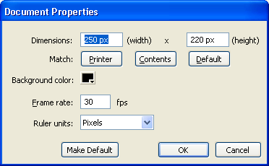
    - Select ‘Background’ and change to Black.
    - Select ‘Frame Rate’ and change this to 30 fps
    - Select ‘Size’ and change this to 250 px (width)x
220 px (height)

- Locate the ‘Bullet’ and ‘Ship’ files and save them to your folders. You need to import these files to the library.
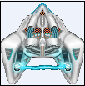
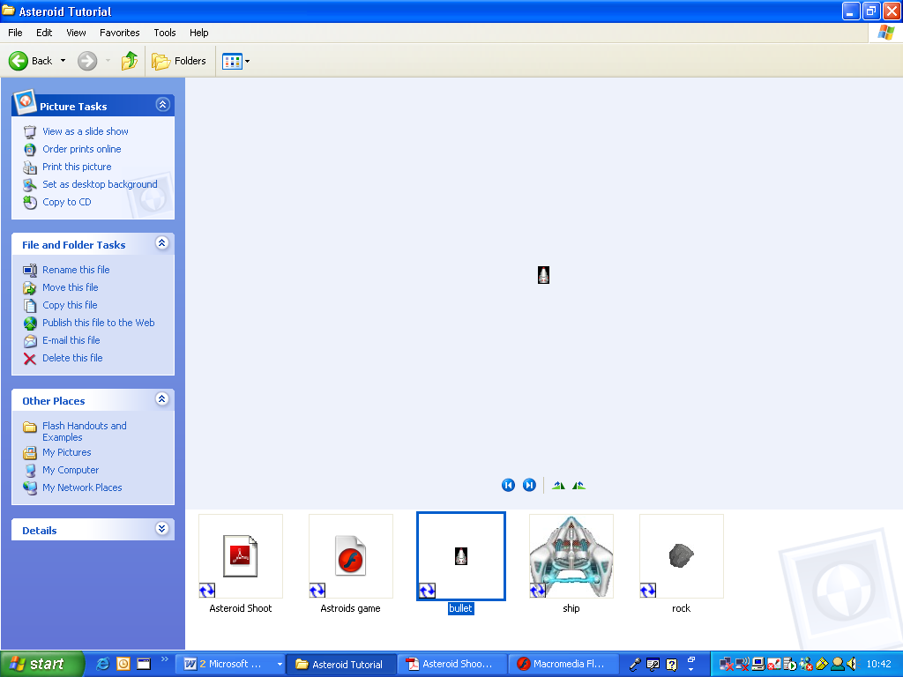
a. Select File>Import>Import to stage…
b. Then find the files and select them. Then press ‘Open’.

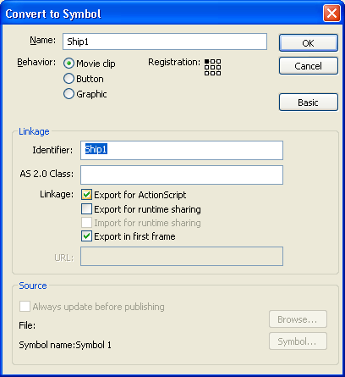
- Select the ‘Ship’ image, by clicking on it. Then go to Modify>convert to symbol. You may need to select the advanced button.

- Next, we need to name the symbol Ship1
- Ensure the button ‘Movie Clip’ is ticked.
- Click on ‘Basic’
- Tick the ‘Export for ActionScript’ box
- The menu should look like this. If it does then click ‘OK’.

- Now do exactly the same for the bullet but call the
symbol Bullet1

- Now delete the bullet and the ship from the stage.
var speed = 6;
var shipMc = this.attachMovie("ship1", "ship1", 10000);
shipMc._y = Stage.height-(shipMc._height+10);
shipMc._x = Stage.width/2 - (shipMc._width/2) ;

function moveShip() {

if (Key.isDown(Key.UP)) {
shipMc._y -= speed;
}
if (Key.isDown(Key.DOWN)) {
shipMc._y += speed;
}
if (Key.isDown(Key.LEFT)) {
shipMc._x -= speed;
}
if (Key.isDown(Key.RIGHT)) {
shipMc._x += speed;
}
}
this.onEnterFrame = function(){
moveShip();
};
- Double click on the layer name ‘Layer 1’ and rename to ‘SHIP’ Select Frame 1

- Click on the Actions bar in the properties to make it visible so we can enter the following code to make the ship move left and right and up and down.

- Go to Control and Test Scene to see if the ship moves from left to right and up and down.

Well done – Stage 1 complete!

